**CSE 343 Project**

**Prototype #2 Report**

Group : Toastware Developers

Project Title : Rent a Car with the Driver

Project Manager : Harun Eren Özkaya

Product Owner : Eray Yaşar

Developer : Berkan Akın

Developer : Süleyman Burak Yaşar

Developer : Yusuf Alperen Dönmez

Developer : Taha Kınalı

**THE USER STORIES**

**CUSTOMER**

Mamoun is a traveler from the United Arabic Emirates visiting Istanbul via plane, when he arrives at the airport, he will need a vehicle. Should he take an Istanbul taxi that is notorious for overcharging foreign travelers? He thoughts not. So, he settles for using an app, called RentaGO that is used for renting a vehicle with a driver. Mamoun is a busy man, when he arrives at the airport, he wants to drive off. From the app he rents a driver with a vehicle in a nearby location. He wants to browse drivers available and filter them according to their estimated pricing, working hours, locations, and ratings. Before he rents drivers services, he wants to get to know them better, so he checks on their profile and reads their biography, skills and spoken language, previous customer reviews, vehicle name, model, and photos, and finally be able to match and chat with a driver so that Mamoun and the driver may speak the details of the travel, like how many hours he wants to rent the driver and their vehicle, and may further negotiate the hourly rate of the travel. And after the trip is over, he wants to leave a review and rate the driver.

**DRIVER**

Ahmet is an experienced tour guide and a car driver; Ahmet has been driving tourists for a long time already. But his business lacks something… The internet! So, he downloads an app called RentaGO where he can provide for his customers faster and more efficiently. First, he wants to setup a profile where he can mention about himself, his talents, and the languages he speaks so that he can be preferable to the customers. He also wants to put his vehicle info (brand, model, etc...) and couple of photographs of the said vehicle and his location of work. After setting up his profile, he is ready to accept customer requests, so he waits for them. If he receives a request from a customer, he wants to be able to chat with them the details of the travel and then make an offer. If everything goes well then, he would like for customers to rate and review their experience so that the future customers can get an idea of how good a tour guide and car driver Ahmet is.

**Sending a request and accepting an offer from a driver as a customer**

**Initial assumption:** A customer wants to rent a driver. The customer has successfully logged on to RentaGO.

**Normal:** A customer chooses a driver from the list of drivers based on the applied filters (location, estimated pricing, working hours, etc..). When he finds a suitable driver, he sends a request to the driver. If the driver accepts that request, they are then prompted to a chatting screen where the customer shares the travel details with the driver and negotiate the hourly rate. Then the driver makes an offer and user accepts that offer.

**What can go wrong:** There may not be a driver with the applied filters. The customer should be informed that there are no drivers available.

The customer accidentally accepted an offer that they don’t want. The customer should be able to cancel the process.

**Other activities:** No known concurrent activities.

**System state on completion:** The customer is directed to the payment screen.

**Sending a request and accepting an offer from a driver with a car as a customer**

**Initial assumption:**

**Normal:** A customer chooses a driver from the list of drivers based on the applied filters (location, estimated pricing, working hours, etc..). When he finds a suitable driver, he sends a request to the driver. If the driver accepts that request, they are then prompted to a chatting screen where the customer shares the travel details with the driver and negotiate the hourly rate. Then the driver makes an offer and user accepts that offer.

**What can go wrong:** There may not be a driver with the applied filters. The user should be informed that there are no drivers available.

**Other activities:**

**System state on completion:** The customer is directed to the payment screen.

**Sending a request and accepting an offer from a driver with a car as a customer**

**Initial assumption:**

**Normal:** A customer chooses a driver from the list of drivers based on the applied filters (location, estimated pricing, working hours, etc..). When he finds a suitable driver, he sends a request to the driver. If the driver accepts that request, they are then prompted to a chatting screen where the customer shares the travel details with the driver and negotiate the hourly rate. Then the driver makes an offer and user accepts that offer.

**What can go wrong:** There may not be a driver with the applied filters. The user should be informed that there are no drivers available.

**Other activities:**

**System state on completion:** The customer is directed to the payment screen.

**Accepting a request and sending an offer to a customer as a driver**

**Initial assumption:** A customer has messaged a driver and sent a request. The driver has successfully logged on to RentaGO.

**Normal:** A driver is informed that they have a customer request from their main menu. To accept the request the driver clicks on the request and then prompted to the chatting screen with the customer. They discuss the travel details with the customer. Then the driver makes an offer to the customer.

**What can go wrong:** The driver made a typo while making an offer and the hourly rate is not as intended. The driver should be able to cancel the process.

**Other activities:** Other customers may try to send a request and contact the driver.

**System state on completion:** If the offer is accepted by the customer the travel will be listed as an “active renting”.

# Project Backlog Documents

Our project has 3 completed sprint now due to misunderstanding scrum system and doing sprints duration is 1 week so we converted it to 2 week from sprint 4.

## Sprint 1

**Date :** 10.10.22 – 17.10.22

**Goal :** Improving ourself about our working areas such as backend or mobile. Learning basic and essential endpoint and server logic system on backend side and learning basic and essential design implementation, navigation system on mobile side.

## Issues:

* Learning Flutter
  + Description : Learning flutter for mobile development
  + Priority : High
  + Type : Task
  + Assignee : Harun Eren Özkaya
  + Status : Completed
* Learning Flutter
  + Description : Learning flutter for mobile development
  + Priority : High
  + Type : Task
  + Assignee : Yusuf Alperen Dönmez
  + Status : Completed
* Learning Flutter
  + Description : Learning flutter for mobile development
  + Priority : High
  + Type : Task
  + Assignee : Berkan Akın
  + Status : Completed
* Learning Node.js
  + Description : Learning Node.js for backend development
  + Priority : High
  + Type : Task
  + Assignee : Süleyman Burak Yaşar
  + Status : Completed
* Learning Node.js
  + Description : Learning Node.js for backend development
  + Priority : High
  + Type : Task
  + Assignee : Eray Yaşar
  + Status : Completed
* Learning Node.js
  + Description : Learning Node.js for backend development
  + Priority : High
  + Type : Task
  + Assignee : Taha Kınalı
  + Status : Completed

**Burtdown Chart :**

**Cumulative Flow Diagram :**

## Sprint 2

**Date :** 17-10.22 – 24.10.22

**Goal :** Developing application’s login and register with client side (mobile) and

server side (backend).

## Issues:

* Login Screen
  + Description : Developing application screen which provides user to login to app
  + Priority : High
  + Type : Task
  + Assignee : Yusuf Alperen Dönmez
  + Status : Uncompleted
* Register Customer Screen
  + Description : Developing application screen which provides customer to register to app
  + Priority : High
  + Type : Task
  + Assignee : Berkan Akın
  + Status : Uncompleted
* Register Driver Screen
  + Description : Developing application screen which provides driver to register to app
  + Priority : High
  + Type : Task
  + Assignee : Harun Eren Özkaya
  + Status : Uncompleted
* Login Backend
  + Description : Developing application backend side which provides user to login.
  + Priority : High
  + Type : Task
  + Assignee : Eray Yaşar
  + Status : Completed
* Register Driver Backend
  + Description : Developing application backend side which provides driver to register to application.
  + Priority : High
  + Type : Task
  + Assignee : Süleyman Burak Yaşar
  + Status : Completed
* Register Customer Backend
  + Description : Developing application backend side which provides customer to register to application.
  + Priority : High
  + Type : Task
  + Assignee : Taha Kınalı
  + Status : Completed

**Burtdown Chart :**

**Cumulative Flow Diagram :**

## Sprint 3

**Date :** 24-10.22 – 31.10.22

**Goal :** Building services of login and register pages of users to make connection with backend. Building backend endpoints of profile of users.

Designing mobile application in Figma. Learning token system in auth.

Learning how to and where can we deploy backend server

## Issues:

* Login Screen
  + Description : Developing application screen which provides user to login to app
  + Priority : High
  + Type : Task
  + Assignee : Yusuf Alperen Dönmez
  + Status : Completed
* Register Customer Screen
  + Description : Developing application screen which provides customer to register to app
  + Priority : High
  + Type : Task
  + Assignee : Berkan Akın
  + Status : Completed
* Register Driver Screen
  + Description : Developing application screen which provides driver to register to app
  + Priority : High
  + Type : Task
  + Assignee : Harun Eren Özkaya
  + Status : Completed
* Profile of Customer Backend
  + Description : Developing application backend side which provides show the customer profile for the users
  + Priority : High
  + Type : Task
  + Assignee : Taha Kınalı
  + Status : Completed
* Profile of Driver Backend
  + Description : Developing application backend side which provides show the driver profile for the users
  + Priority : High
  + Type : Task
  + Assignee : Süleyman Burak Yaşar
  + Status : Completed
* Design Application Theme on Figma
  + Description : Design all application
  + Priority : Moderate
  + Type : Task
  + Assignee : Harun Eren Özkaya
  + Status : Completed
* Learn and Explain Usage of Token System
  + Description : Learning token auth system
  + Priority : Moderate
  + Type : Task
  + Assignee : Taha Kınalı
  + Status : Completed
* Learn and Explain Deployment of Server
  + Description : Learning deployment of server
  + Priority : Moderate
  + Type : Task
  + Assignee : Süleyman Burak Yaşar
  + Status : Completed
* Learn Flutter
  + Description : Because of it is hard to implement mobile , we need to one person for mobile team and we decided transfer one person to mobile team so this task is the learning Flutter.
  + Priority : High
  + Type : Task
  + Assignee : Eray Yaşar
  + Status : Completed

**Burtdown Chart :**

**Cumulative Flow Diagram :**

**Sprint 4**

**Date :**31-10.22 – 14.11.22

**Goal :** This sprint includes tasks that involve preparing the documentation of the 1st prototype until November 5th. User story decumentation, project backlog documentation, use case diagrams and test cases are the necessary tasks for this prototype. Other tasks are those that we continue to develop the application for the remaining time after the prototype. .The tasks that have the biggest share among them are the development of Profile, Main and Edit User pages and the development of the backend of these pages.

**Issues:**

* User Story and Its Related Scenarios Documentation
  + Description : Create user story and sceneraios documentation for prototype 1.
  + Priority : High
  + Type : Task
  + Assignee : Yusuf Alperen Dönmez
  + Status : Completed
* Project Backlog Documentation
  + Description : Create project backlog documentation for prototype 1.
  + Priority : High
  + Type : Task
  + Assignee : Harun Eren Özkaya
  + Status : Completed
* Use case diagrams
  + Description : Create use case diagrams for prototype 1
  + Priority : High
  + Type : Task
  + Assignee : Berkan Akın
  + Status : Completed
* Test Cases 1
  + Description : Create test cases documentation for prototype 1.
  + Priority : High
  + Type : Task
  + Assignee : Taha Kınalı
  + Status : Completed
* Test Cases 2
  + Description : Create test cases documentation for prototype 1.
  + Priority : High
  + Type : Task
  + Assignee : Süleyman Burak Yaşar
  + Status : Completed
* Test Cases 3
  + Description : Create test cases documentation for prototype 1.
  + Priority : High
  + Type : Task
  + Assignee : Eray Yaşar
  + Status : Completed
* Learn and Explain Usage of Token System
  + Description : Learning token auth system
  + Priority : Moderate
  + Type : Task
  + Assignee : Taha Kınalı
  + Status : Completed
* Customer Register Page Backend Connection
  + Description : Create connection between customer register page and its backend
  + Priority : High
  + Type : Task
  + Assignee : Berkan Akın
  + Status : Completed
* Server Deployment
  + Description : Learn how to deploy server.
  + Priority : Low
  + Type : Task
  + Assignee : Süleyman Burak Yaşar
  + Status : Uncompleted
* Main Customer Backend
  + Description : Develop backend for main customer page.
  + Priority : High
  + Type : Task
  + Assignee : Taha Kınalı
  + Status : Uncompleted
* Main Driver Backend
  + Description : Develop backend for main driver page.
  + Priority : Moderate
  + Type : Task
  + Assignee : Süleyman Burak Yaşar
  + Status : Uncompleted
* Edit Customer Backend
  + Description : Develop backend for edit customer page.
  + Priority : Moderate
  + Type : Task
  + Assignee : Taha Kınalı
  + Status : Uncompleted
* Edit Driver Backend
  + Description : Develop backend for edit driver page.
  + Priority : Moderate
  + Type : Task
  + Assignee : Süleyman Burak Yaşar
  + Status : Uncompleted
* Photo Storage Research
  + Description : Learn how to store photos.
  + Priority : Moderate
  + Type : Task
  + Assignee : Taha Kınalı
  + Status : Uncompleted
* Driver Profile Page
  + Description : Develop mobile page for driver’s profile
  + Priority : Moderate
  + Type : Task
  + Assignee : Harun Eren Özkaya
  + Status : Uncompleted
* Customer Profile Page
  + Description : Develop mobile page for customer profile
  + Priority : Moderate
  + Type : Task
  + Assignee : Berkan Akın
  + Status : Uncompleted
* Main Driver Page
  + Description : Develop mobile page for driver’s main page
  + Priority : Moderate
  + Type : Task
  + Assignee : Eray Yaşar
  + Status : Uncompleted
* Edit Driver and Customer Pages
  + Description : Develop mobile pages for edit informations about drivers and customers
  + Priority : Moderate
  + Type : Task
  + Assignee : Yusuf Alperen Dönmez
  + Status : Uncompleted

**Burtdown Chart :**

**Cumulative Flow Diagram :**

**Sprint 5**

Date :21-11.22 – 05.12.22

Goal : This spring goals are developing backend and mobile sides of profile and main features of this application. Also we must prepare documentations of second prototype.

Issues:

* User Story and Its Related Scenarios Documentation
  + Description : Create user story and sceneraios documentation for prototype 2.
  + Priority : High
  + Type : Task
  + Assignee : Yusuf Alperen Dönmez
  + Status : Completed
* Project Backlog Documentation
  + Description : Create project backlog documentation for prototype 2.
  + Priority : High
  + Type : Task
  + Assignee : Harun Eren Özkaya
  + Status : Completed
* Use case diagrams
  + Description : Create use case diagrams for prototype 2
  + Priority : High
  + Type : Task
  + Assignee : Berkan Akın
  + Status : Completed
* Test Cases 1
  + Description : Create test cases documentation for prototype 2.
  + Priority : High
  + Type : Task
  + Assignee : Taha Kınalı
  + Status : Completed
* Test Cases 2
  + Description : Create test cases documentation for prototype 2.
  + Priority : High
  + Type : Task
  + Assignee : Süleyman Burak Yaşar
  + Status : Completed
* Test Cases 3
  + Description : Create test cases documentation for prototype 2.
  + Priority : High
  + Type : Task
  + Assignee : Eray Yaşar
  + Status : Completed
* Class Diagrams Documentation
  + Description :
  + Priority : High
  + Type : Task
  + Assignee : Harun Eren Özkaya
  + Status : Completed
* Class Diagrams Documentation
  + Description :
  + Priority : High
  + Type : Task
  + Assignee : Harun Eren Özkaya
  + Status : Completed
* Sequence Diagrams Documentation
  + Description :
  + Priority : High
  + Type : Task
  + Assignee : Süleyman Burak Yaşar
  + Status : Completed
* Context Model Documentation
  + Description :
  + Priority : High
  + Type : Task
  + Assignee : Eray Yaşar
  + Status : Completed
* Process Model Documentation
  + Description :
  + Priority : High
  + Type : Task
  + Assignee : Taha Kınalı
  + Status : Completed
* Server Deployment
  + Description : Learn how to deploy server.
  + Priority : Moderate
  + Type : Task
  + Assignee : Süleyman Burak Yaşar
  + Status : Completed
* Main Customer Backend
  + Description : Develop backend for main customer page.
  + Priority : High
  + Type : Task
  + Assignee : Taha Kınalı
  + Status : Completed
* Main Driver Backend
  + Description : Develop backend for main driver page.
  + Priority : High
  + Type : Task
  + Assignee : Süleyman Burak Yaşar
  + Status : Completed
* Edit Customer Backend
  + Description : Develop backend for edit customer page.
  + Priority : High
  + Type : Task
  + Assignee : Taha Kınalı
  + Status : Completed
* Edit Driver Backend
  + Description : Develop backend for edit driver page.
  + Priority : High
  + Type : Task
  + Assignee : Süleyman Burak Yaşar
  + Status : Completed
* Photo Storage Research
  + Description : Learn how to store photos.
  + Priority : Moderate
  + Type : Task
  + Assignee : Taha Kınalı
  + Status : Completed
* Driver Profile Page
  + Description : Develop mobile page for driver’s profile
  + Priority : High
  + Type : Task
  + Assignee : Harun Eren Özkaya
  + Status : Completed
* Driver Profile Page
  + Description : Develop mobile page for driver’s profile
  + Priority : High
  + Type : Task
  + Assignee : Harun Eren Özkaya
  + Status : Completed
* Customer Profile Page
  + Description : Develop mobile page for customer profile
  + Priority : High
  + Type : Task
  + Assignee : Berkan Akın
  + Status : Completed
* Main Driver Page
  + Description : Develop mobile page for driver’s main page
  + Priority : High
  + Type : Task
  + Assignee : Eray Yaşar
  + Status : Completed
* Edit Driver and Customer Pages
  + Description : Develop mobile pages for edit informations about drivers and customers
  + Priority : High
  + Type : Task
  + Assignee : Yusuf Alperen Dönmez
  + Status : Completed

**Burtdown Chart :**

**Cumulative Flow Diagram :**

**Class Diagram**

* Diagram doesn’t fit this documentation so we uploaded to a image service.

**Class Diagram Link :** <https://ibb.co/HzWYJLg>

**UML DIAGRAMS**

**a. Context Model** 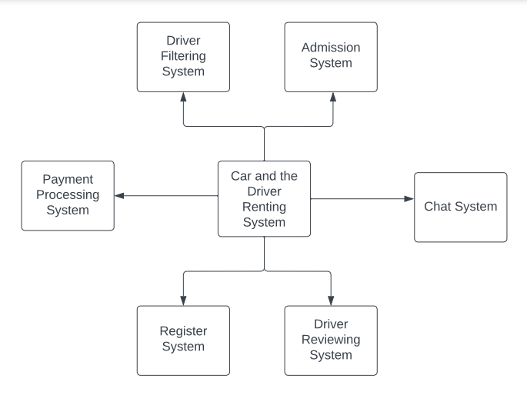

**b. Process Model**

Note: Process model is in zip file.

**c. Use-case diagram**

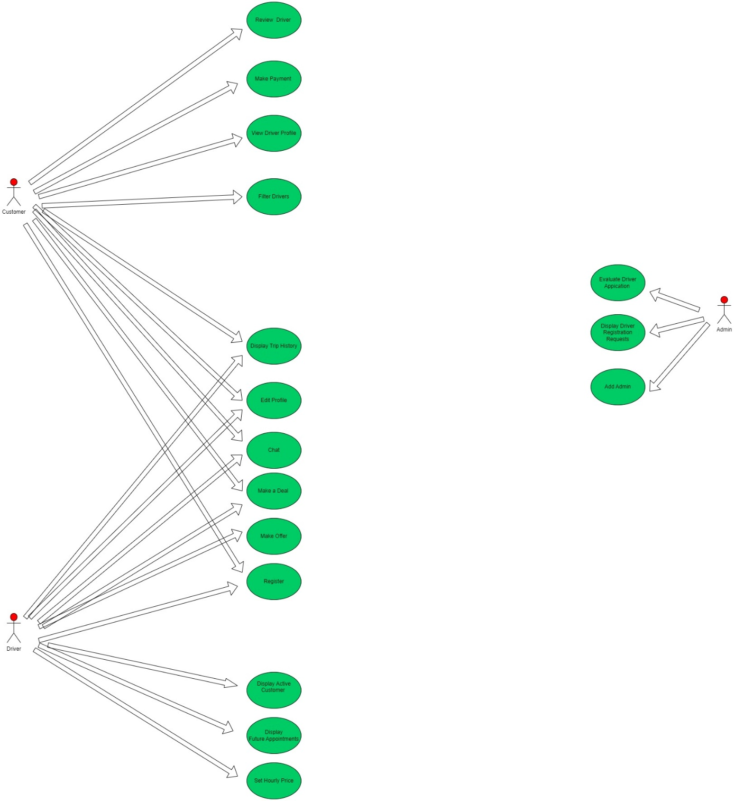

**Detailed Tables**

|  |  |
| --- | --- |
| System | Rent a car app |
| Use Case | Review  Driver |
| Actors | Customer |
| Data | Customer review |
| Stimulus | When the trip is Done |
| Response | Review made is saved to the customers profile with additional trip information |
| Comments | Review is also show up at drivers profile |

|  |  |
| --- | --- |
| System | Rent a car app |
| Use Case | Make Payment |
| Actors | Customer |
| Data | Credit card information |
| Stimulus | Customer and Driver makes a deal |
| Response | A prompt massage showing that payment is successfully made |
| Comments | Payment required to start the trip after agreed on chat |

|  |  |
| --- | --- |
| System | Rent a car app |
| Use Case | View Driver Profile |
| Actors | Customer |
| Data | Driver information, trip history, reviews and ratings. |
| Stimulus | Customer searches for a driver |
| Response | Drivers profile is displayed |
| Comments | Customer views information, trip history, reviews and ratings. |

|  |  |
| --- | --- |
| System | Rent a car app |
| Use Case | Filter Drivers |
| Actors | Customer |
| Data | Filter parameters (price, location, gender, language, car age, rating etc.) |
| Stimulus | Customer searches fora driver with filter parameters. |
| Response | When the filters a applied appropriate drivers are displayed |
| Comments | İf there are no appropriate drivers then no drivers are shown |

|  |  |
| --- | --- |
| System | Rent a car app |
| Use Case | Display Trip History |
| Actors | Customer, Driver |
| Data | Driver information, trip history, reviews and ratings. |
| Stimulus | Customer searches for a driver |
| Response | Drivers profile is displayed |
| Comments | Customer views information, trip history, reviews and ratings. |

|  |  |
| --- | --- |
| System | Rent a car app |
| Use Case | Edit profile |
| Actors | Customer, Driver |
| Data | User information( name surname age birthday, mail, etc..) |
| Stimulus | User intends to update their personal information. |
| Response | Users personal information is updated accordingly |
| Comments | Due to systemic conditions, e-mail and phone numbers cannot be changed, and all remaining user information can be changed. |

|  |  |
| --- | --- |
| System | Rent a car app |
| Use Case | Chat |
| Actors | Customer, Driver |
| Data | Chat conversations |
| Stimulus | Customer intends to rent a driver |
| Response | Communication between driver and customer |
| Comments | Only customers can initiate the chat. Drivers cannot directly communicate with customers. |

|  |  |
| --- | --- |
| System | Rent a car app |
| Use Case | Make a Deal |
| Actors | Customer, Driver |
| Data | Location, Hourly Price, Duration |
| Stimulus | Driver sends an offer to the Customer |
| Response | Customer is directed to payment page |
| Comments | İn case customer declines make by the driver. Driver is informed about it |

|  |  |
| --- | --- |
| System | Rent a car app |
| Use Case | Make Offer |
| Actors | Driver |
| Data | Location, Hourly Price, Duration |
| Stimulus | Driver and Customer discuss the trip details and the driver prepares a suitable offer for the customer |
| Response | The offer is submitted to the approval of the customer. |
| Comments | The driver sets a suitable price for the customer and sends the travel package |

|  |  |
| --- | --- |
| System | Rent a car app |
| Use Case | Register |
| Actors | Customer, Driver |
| Data | Customer and Driver İnformation |
| Stimulus | Customer and driver's request to enter the system |
| Response | Registration of the user in the system. |
| Comments | User and phone number are set here and cannot be changed later. |

|  |  |
| --- | --- |
| System | Rent a car app |
| Use Case | Display Active Customer |
| Actors | Driver |
| Data | Trip Details |
| Stimulus | The driver and the customer agree, then the driver enters their profile page |
| Response | Active Customer and Trip Details are shown at the drivers main page. |
| Comments | If driver has no active customers then active customer part in the profile is empty. |

|  |  |
| --- | --- |
| System | Rent a car app |
| Use Case | Display Future Appointments |
| Actors | Driver |
| Data | Trip details, customer information |
| Stimulus | The driver and the customer agree, then the driver enters their profile page |
| Response | Future appointment are shown at the drivers main page. |
| Comments | If driver has future appointments then future appointment part in the profile is empty. |

|  |  |
| --- | --- |
| System | Rent a car app |
| Use Case | Set Hourly Price |
| Actors | Driver |
| Data | Hourly Price |
| Stimulus | driver new registration or update own profile |
| Response | The hourly rate is determined and changed. |
| Comments | The updated fee is visible to the customer. The current fee does not change from the active customer. |

|  |  |
| --- | --- |
| System | Admin Panel |
| Use Case | Evaluate Driver Application |
| Actors | Admin |
| Data | Driver information |
| Stimulus | Driver registers to the system |
| Response | Whether the driver is suitable for the system |
| Comments | Drivers whose documents are not verified cannot be registered in the system. |

|  |  |
| --- | --- |
| System | Admin Panel |
| Use Case | Display Driver Registration Requests |
| Actors | Admin |
| Data | Driver information |
| Stimulus | Driver registers to the system |
| Response | Display driver registration requests |
| Comments | Where drivers' applications are displayed |

|  |  |
| --- | --- |
| System | Admin Panel |
| Use Case | Add Admin |
| Actors | Admin |
| Data | Admin application information |
| Stimulus | A person tries to create an account from the admin panel. |
| Response | New admin is added to the system |
| Comments | The newly added admin has the authority to add drivers. |

**d. Sequence Diagrams**

Note: Sequence Diagrams is in zip file.

**Working Graphical Interface and Backend Services**

**Backend Services**

Backend api tests were done through postman. You can see the results by clicking the link.

Link: <https://documenter.getpostman.com/view/23857375/2s8YzL4m3C#37ca8e3a-63aa-4f31-bbab-e095f755e272>

**Application Interface**

Note: application interface video is in zip file.

**Test Cases**

Note: test cases are in zip file.